**Solution Design Document for Email Monitoring System**

**1. Introduction**

This document outlines the design of an email monitoring system aimed at providing administrators and users with the capability to monitor specific email inboxes and perform predefined actions on incoming emails.

**2. System Overview**

The email monitoring system facilitates the following functionalities:

* Monitoring incoming emails in designated shared mailboxes.
* Registering and unregistering shared mailboxes for monitoring.
* Starting, stopping, and viewing the status of the monitoring service.
* Taking predefined actions on emails based on processing logic.
* Generating logs for monitoring and troubleshooting purposes.

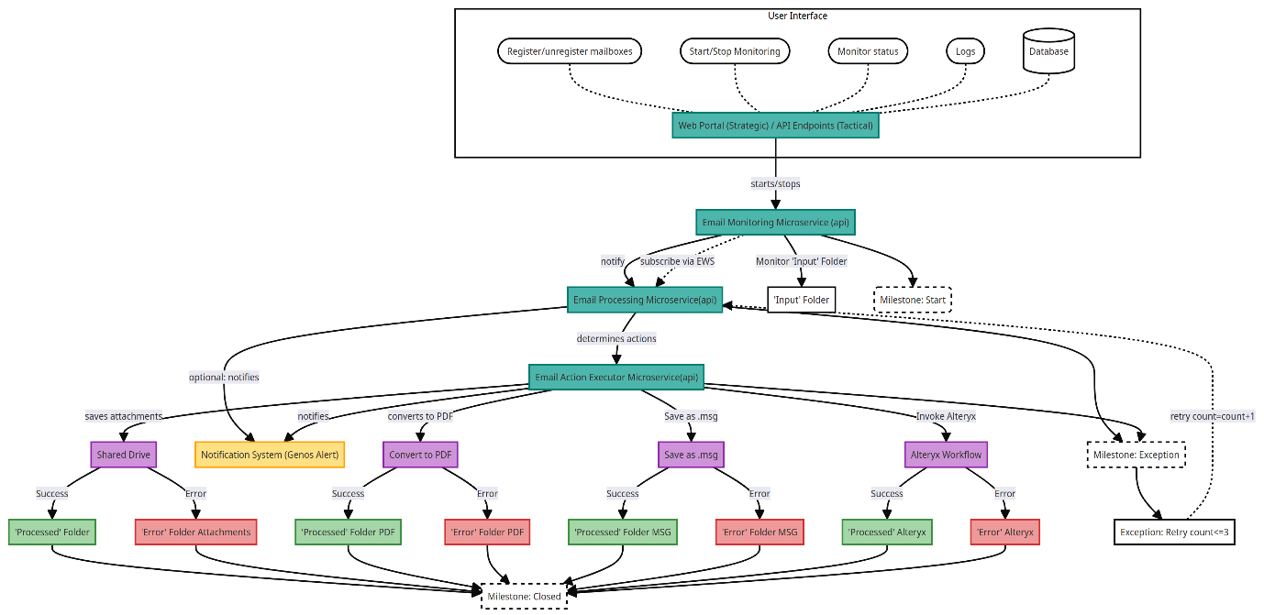

**3. System Architecture**

The system architecture comprises the following key components:

**Web Portal:**

* Central user interface for administrators and users.
* Features include mailbox registration, service control, and log access.

**Database:**

* Stores information about registered shared mailboxes.
* Used by the Email Monitoring Service (EMS) to determine which mailboxes to monitor.

**Email Monitoring Service (EMS):**

* Monitors incoming emails from specified shared mailboxes.
* Controlled via commands from the Web Portal.

**Email Processing Service & Action Executor Service:**

* Combined service for processing incoming emails and executing predefined actions.
* Interacts with external systems when necessary to complete actions.

**Logging Mechanism & Genos Alerts:**

* Records exceptions and significant events during system operation.
* Logs accessible through the Web Portal for monitoring and troubleshooting.
* Genos Alerts provide real-time notifications for critical events.

**4. Data Flow**

* Users interact with the Web Portal to manage mailboxes and service operation.
* The Web Portal communicates with the Database for mailbox registration.
* Commands from the Web Portal control the EMS operation.
* The EMS retrieves mailbox information from the Database and monitors specified mailboxes.
* Incoming emails are processed by the Email Processing Service & Action Executor Service.
* Processed emails are stored, and exceptions/events are logged.
* Logs are accessible through the Web Portal for monitoring and troubleshooting.

**5. Error Handling**

* Exceptions and errors during email processing or service operation are logged.
* Genos Alerts notify administrators of critical errors.
* Emails with errors are stored in a designated error folder for investigation.

**6. Security Considerations**

* Secure authentication mechanisms for Web Portal access.
* Authorization controls to restrict user access based on roles.
* Encryption of sensitive data (email content, attachments) in transit and at rest.

**7. Future Considerations**

* System extension for additional email actions.
* Integration with other systems (ticketing, CRM).
* Implementation of scalability features for increased email volume or mailbox count.

**8. Appendix (Optional)**

* API specifications for component communication.
* Data formats for email storage and processing.
* Detailed error handling procedures.